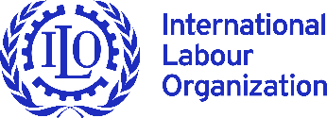
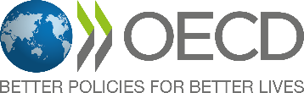
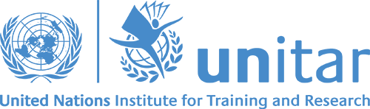
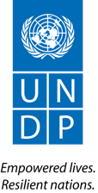
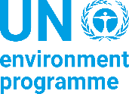
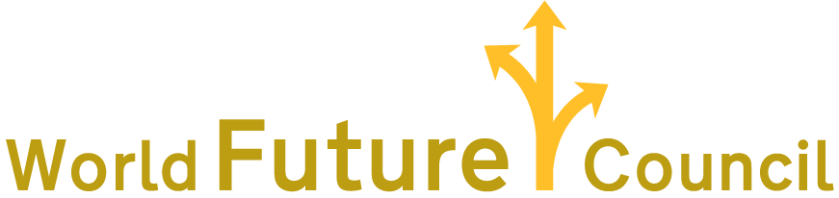

Future Policy Award:
Protection from Hazardous Chemicals

Call for Nominations

Deadline: 30 June 2020

BACKGROUND
Celebrating Laws and Policies Protecting from Hazardous Chemicals

The Future Policy Award showcases legislation and policies that create better living conditions for current and future generations. The aim of the award is to raise global awareness for exemplary laws and policies and speed up policy action towards a healthy planet and just, sustainable and peaceful societies. The Future Policy Award is the first award for laws and policies and is celebrated on an international level. Each year the World Future Council (WFC) focuses on one topic on which policy progress is particularly urgent, and receives nominations from all over the world for laws, policies or legal frameworks that are inspiring, innovative and effective. As consumption and production of chemicals are rapidly increasing in emerging economies, we are specifically interested in policies from developing countries and countries with economies in transition.
The WFC’s Future Policy Award is working in partnership with the United Nation Environment Programme (UNEP), the Strategic Approach to International Chemicals Management (SAICM), the International Labour Organisation (ILO), the Organisation for Economic Co-operation and Development (OECD) and the United Nations Institute for Training and Research (UNITAR), United Nations Development Programme (UNDP), and with the support of the German Federal Ministry for the Environment, Nature Conservation, and Nuclear Safety (BMU), the German Environment Agency (UBA), the Michael Otto Foundation and the Jua Foundation to highlight exemplary laws and policies that protect people and the environment from hazardous chemicals. The focus will be to highlight laws, policies and legal frameworks that minimize the adverse effects of chemicals exposure on human health, with a focus on children’s health and the environment.

Tackling the global challenge of chemicals impacting our environment and health

Around 40,000-60,000 chemicals are in commerce worldwide. Particularly problematic are chemicals that end up in our environment, in the food chain and soil, air and drinking water and accumulate in our bodies. Our environment can be contaminated by hazardous chemicals, including polychlorinated biphenyls (PCBs), heavy metals and pesticides. This can cause irreversible harm to the health of humans, fauna, flora, marine life and to the planet. Many hazardous chemicals are found in food systems and the food we eat with potential harmful long-term effects.

There are enormous costs associated with unsound management of chemicals and waste. The World Health Organization estimated the burden of disease from exposure to selected chemicals at 1.6 million lives in 2016. Costs from neurobehavioral deficits caused by certain exposure to chemicals were estimated to be more than 170 billion USD per year in the European Union alone.

In recent years, the demand for protection of human rights, especially children and vulnerable populations from toxics is emerging. Children are more vulnerable than adults due to ratio between body weight and levels of exposure and are also more sensitive to developmental growth spurts. There is a “silent pandemic” of disability and disease associated with exposure to toxics and pollution during childhood. Toxic chemicals may interfere with the normal expression of genes, brain development, the function of hormones and other processes necessary for children to grow into healthy adults. Nowadays, the majority of children are born “pre-polluted” in the uterus with numerous contaminants that impact on several of their rights. Studies measured quite a number of toxic and hazardous chemicals in children before birth through their mother’s exposure and this increases after birth. Although chemical exposure can pose a risk to all, males and females have different susceptibility to chemical exposure and are differently affected with regard to physical conditions or reproductive health. In addition, children, adolescents and women working in the informal sector seldom receive trainings related to the chemicals. They are also more affected through the use of domestic personal items or household cleaning products.

Despite significant actions already taken for decades, the Global Chemicals Outlook II indicates that the global goal to minimize adverse impacts of chemicals and waste will not be achieved by 2020. Whilst solutions exist, more ambitious worldwide actions by all stakeholders is urgently required. The size of the global chemical industry exceeded 5 trillion USD in 2017 and it is projected to double by 2030 (UNEP 2019). Furthermore, consumption and production are rapidly increasing in emerging economies. Global supply chains, and the trade of chemicals and products, are becoming increasingly complex. This will increase global chemical releases, exposures, concentrations and adverse health and environmental impacts.

The 2030 Agenda for Sustainable Development incorporates chemicals and waste as key factors for achieving the Sustainable Development Goals (SDGs). While chemicals and waste are cross-cutting issues across the 2030 Agenda, they are also clearly embedded into SDG 3 on good health and well-being, SDG 12 related to responsible consumption and production and SDG 6 on clean water and sanitation.

In moving forward, it is absolutely critical that the sound management of chemicals and waste is strengthened through inclusive, effective, inspiring and innovative laws and policies globally to protect future generations and contribute to the 2030 Agenda.

WHAT ARE WE LOOKING FOR?
Policies, laws and legal frameworks that strengthen the sustainable management of chemicals across the lifecycle
We seek nominations of impacting policies, laws and legal frameworks that protect human health, including the health of children, and the environment with policies including
- Comprehensive chemical policies
- Specific policies on
  - The protection of human health from chemicals across the lifecycle
  - Chemicals in plastic products
  - Highly hazardous pesticides
  - Lead in Paint
  - Policies that tackle hazardous (child) labour dealing with chemicals
  - Environmentally persistent pharmaceutical pollutants

Laws, policies and frameworks can be national, subnational, regional or local in nature and must:
- be in existence for long enough (2-3 years minimum) to demonstrate its effective implementation and impact;
- deliver identifiable improvements;
- be replicable under similar circumstances; and
- take into account systemic aspects, reflecting the WFC’s holistic and integrated perspective, in line with the 7 Future Justice Principles adopted by the WFC.

PROCESS
Step 1. Call for Nomination
To facilitate the nomination process, we have developed a template that you will find in the Annex). We kindly request you to send your nomination(s) to Christiane Schnöckel fpa@worldfuturecouncil.org. Anyone may nominate up to three acts, laws, policies, national action plans, programmes, decrees or ordinances of a country, state, region or municipality.

Step 2. The Selection Process
The research team will apply the WFC Future Justice Policy Principles and other indices to the nominations. We will then provide a shortlist of laws, policies and legal frameworks for consideration by an international jury of experts.

Step 3. Recognition of the winners of the Future Policy Award
The winners of the Future Policy Award will be celebrated at a high-level award ceremony at the fifth session of the International Conference on Chemicals Management (ICCM5) from 5 to 9 July 2021 held in Bonn (Germany). The award ceremony will be convened by the WFC in partnership with UNEP, SAICM, ILO, OECD, UNITAR and UNDP with the support of BMU, UBA, the Michael Otto Foundation and the Jua Foundation.
CONVENING PARTNER
The World Future Council brings the interests of future generations to the centre of law and policy making. The Council addresses challenges to our common future and identifies and promotes effective legislative and policy solutions among decision makers. www.worldfuturecouncil.org
SUPPORTING PARTNERS
About the United Nations Environment Programme (UNEP)
The United Nations Environment Programme (UNEP) is the leading global environmental authority that sets the global environmental agenda, promotes the coherent implementation of the environmental dimension of sustainable development within the United Nations system, and serves as an authoritative advocate for the global environment.www.unenvironment.org/. UNEP administers the Strategic Approach to International Chemicals Management (SAICM). SAICM is a multi-stakeholder and multi-sectoral policy framework to promote chemical safety and health around the world under the roof of the United Nations Environment Programme, convening actors to work together on chemicals issues and catalyzing actions across sectors. www.saicm.org/.
About the International Labour Organization (ILO)
The International Labour Organization (ILO) is the United Nations agency for the world of work. It sets international labour standards, promotes rights at work and encourages decent employment opportunities, the enhancement of social protection and the strengthening of dialogue on work-related issues. The ILO was founded in 1919, in the wake of a destructive war, to pursue a vision based on the premise that universal, lasting peace can be established only if it is based on social justice. The only tripartite U.N. agency, the ILO brings together governments, employers and workers of 187 member States, to set labour standards, develop policies and devise programmes promoting decent work for all women and men. www.ilo.org

About the Organisation for Economic Co-operation and Development (OECD)
The Organisation for Economic Co-operation and Development (OECD) is an international organisation that works to build better policies for better lives. Our goal is to shape policies that foster prosperity, equality, opportunity and well-being for all. We draw on almost 60 years of experience and insights to better prepare the world of tomorrow. Together with governments, policy makers and citizens, we work on establishing evidence-based international standards and finding solutions to a range of social, economic and environmental challenges. From improving economic performance and creating jobs to fostering strong education and fighting international tax evasion, we provide a unique forum and knowledge hub for data and analysis, exchange of experiences, best-practice sharing, and advice on public policies and international standard-setting.

About the United Nations Institute for Training and Research (UNITAR)
The United Nations Institute for Training and Research (UNITAR) provides innovative learning solutions to individuals, organizations and institutions to enhance global decision-making and support country-level action for shaping a better future. UNITAR was created in 1963 to train and equip young diplomats from newly-independent UN Member States with the knowledge and skills needed to navigate through the diplomatic environment. Over the years, UNITAR has acquired unique expertise and experience in designing and delivering a variety of training activities. We have become a leading institute in the provision of customized and creative learning solutions to institutions and individuals from both public and private sectors. With a strategy fully focused on achieving the Sustainable Development Goals (SDGs), UNITAR supports Governments to implement the 2030 Agenda. www.unitar.org

About the United Nations Development Programme (UNDP)
The United Nations Development Programme (UNDP) works in about 170 countries and territories, helping to achieve the eradication of poverty, and the reduction of inequalities and exclusion. We help countries to develop policies, leadership skills, partnering abilities, institutional capabilities and build resilience in order to sustain development results. The sound management of chemicals and wastes is an important component of UNDP’s efforts to achieve sustainable, inclusive and resilient human development and the Sustainable Development Goals (SDGs). UNDP advocates for integrating chemicals management priorities into national environmental and poverty reduction planning frameworks, helps countries access financial and technical resources, and provides technical assistance and implementation support to improve the holistic management of chemicals and waste at national, regional and global levels.
https://www.undp.org/content/undp/en/home.html
This project is financially supported by the German Federal Ministry for the Environment, Nature Conservation and Nuclear Safety and the German Environment Agency. The publisher is responsible for the content of this publication. https://www.bmu.de/en https://www.umweltbundesamt.de/en
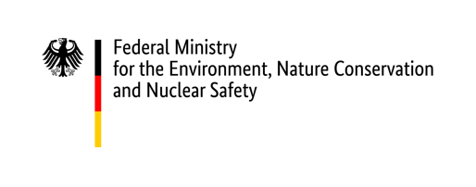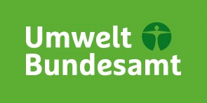
Who can nominate?
We welcome nominations from representatives of international organizations, academia, non-governmental organizations, parliaments, governments, government agencies, and others.
NOMINATION FORM
The official deadline for nominations is 30 June 2020. Please submit your nomination as follows:
- in the enclosed nomination form by email to Ms Christiane Schnöckel at fpa@worldfuturecouncil.org. For further information, please visit: www.worldfuturecouncil.org/future_policy_award.html.

Nomination Form - Future Policy Award
Full Name: Your answer | Organisation: Your answer
Email: Your answer | Address: Your answer
Tel./Skype: Your answer
Briefly describe your involvement with the nominated law or policy: Your answer
Official title of the nominated law or policy:
Provide the full name of the nominated law or policy. Include a link to the legal text or enclose the text as attachment to your email.
Your answer
City / country where it is implemented:  Indicate country, state, region or municipality.  Your answer | Year implementation started:  Indicate the year when implementation started. If different, indicate also year of its adoption.  Your answer
Stakeholders and beneficiaries
Indicate who has introduced the law or policy. Indicate which ministries / departments are now responsible for its implementation. Provide, if possible, full contact details of the people in charge. Indicate also other organizations involved in its implementation and beneficiaries.

Entity / Ministry / Department that introduced the law or policy: Your answer

Ministries / Departments responsible for the policy / overseeing implementation: Your answer
Full Name: Your answer
Position: Your answer
Email: Your answer
Phone: Your answer

Other organizations key/contributing to implementation: Your answer

Beneficiaries: Your answer
Context in which the law or policy was enacted
Indicate what is the problem this policy is tackling and how was the policy formulated and adopted (which processes led to the policy’s formulation and adoption, who were the main stakeholders, who was consulted on the policy and how? Was there public participation/civil society, etc.). Provide also information if the policy has since then been evaluated, reviewed and/or amended.

- Problem(s) tackled: Your answer

- Processes that led to the policy’s formulation and adoption: Your answer

- Evaluation / review / amendment since the policy’s adoption: Your answer
Purpose and objectives
What are the aims/goals stated by the policy itself?
Your answer
Methods and modalities
Provide answers to the questions below.

- What are the policy’s key features?
- Have stakeholders implemented these measures? To what extent? Are there any problems?: Your answer
- Who is monitoring and evaluating the implementation? Your answer
- Is the policy being regularly reviewed? Has there been continuous consultation and involvement of the various stakeholders/beneficiaries?: Your answer
- Is the law or policy enforced, e.g. through mandatory compliance, legally enforceable standards, inspections, audits, review, sanctions for non-compliance? Who is responsible for enforcement?: Your answer
- What are the costs of implementation? Who is covering these costs? Is there a sustainable budget provision (or are there potential budget cuts, change of political situation, etc.)?: Your answer
- Future development: Will the policy continue to be implemented within the next two years (2021-2022) or are there any potential threats (budget cuts, change of political situation, etc.)?: Your answer
- Is the policy due to be reviewed, evaluated, amended, etc. soon, are there additional policies being formulated to enhance implementation, etc. Which elements still need improvement?: Your answer
Results, impact and influence

A. Three measurable outputs
Indicate, for example, the policy’s annual budget, the number of people protected against chemicals, of trainings organized, of services provided, of toolkits produced, etc.
1. Your answer
2. Your answer
3. Your answer

B. Impacts that the law or policy has so far achieved
How have the outputs of the law or policy transformed the reality? How has the policy impacted the health of people and the environment? For example, the policy led to a decrease of the percentage of cancer in a certain region, etc.
1. Your answer
2. Your answer
3. Your answer
Transferability: Do you know if this law/policy has been replicated by other cities, regions or countries? If so, where?
If this is not yet the case, describe to what extent it is transferable and applicable to other countries.
Your answer
Please explain the reasons why this law/policy should be seen as a ‘best law/policy’.
Please provide up to three reasons outlining why the policy should win a Future Policy Award. Why it stands out? What makes it unique? What is particularly innovative? It could also be that it is under threat, etc.
- Your answer
- Your answer
- Your answer
Experts of the policy or law that we can contact or interview for further information:
If possible, indicate an expert for each category (policymaker, civil society and academia). Provide the experts’ full contact details.

Policymaker informant:
Full Name: Your answer
Position, Organization: Your answer
Email: Your answer
Phone: Your answer

Civil society informant:
Full Name: Your answer
Position, Organization: Your answer
Email: Your answer
Phone: Your answer

Academic informant:
Full Name: Your answer
Position, Organization: Your answer
Email: Your answer
Phone: Your answer
Sources of information on this law/policy:
Indicate all relevant information that is available online. Enclose all other relevant information as attachments to your email. We are particularly interested in receiving evaluation reports and annual reports of implementation about the law or policy.
Your answer

Thank you for taking the time to submit this nomination.

You can find more information about the 7 Principles that have been adopted by the WFC: https://www.worldfuturecouncil.org/seven-principles/

